Ancient Egyptian Silhouette Art
LO: To explore colour gradient
Today’s task is to explore the technique of using a gradient of colour in artwork, and creating an Egyptian themed silhouette picture upon a sunset background.
So what is GRADIENT? (please learn this as an Art keyword)
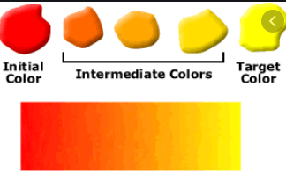
Colour gradient is a gradual blending from one colour to another. This blending can occur between colours of the same tone (from light blue to navy blue), colours of two different tones (from blue to yellow), or even between more than two colours (from blue to purple to red to orange)
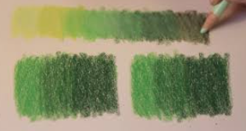
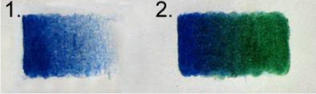

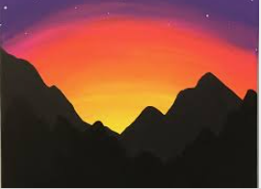
We are going to be using a palette of colours like this yellow/orange/red one to produce our sunset.
If you want to be more experimental, you could introduce some blues and purples to show the night sky like this:
I understand that not everyone has a lot of art materials so, just try your best with what you have. If you don’t have paint you could use coloured pencils or even just an HB pencil and try to recreate the different shading pressures we practised in class in September (ages ago! ).
It is also likely you won’t have black paper, but you could paint or colour some in and use that to draw your silhouette on.
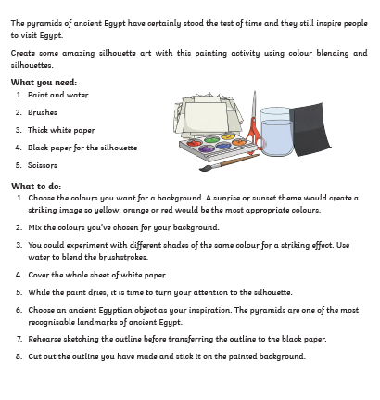
Examples I have found for inspiration:
